

***2ND HIGH SCHOOL OF DRAPETSONA***

***COMENIUS 2010 -2012***

**THE INFLUENCES OF GREEK ARCHITECTURE IN Renaissance ITALY**

 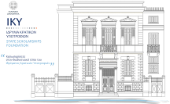

**AUTHORS  
Maria Ventouri  
Anna Saltouridou**

Around the 15th century AD the theocratic spirit and the conservatism prevailed in Europe began to decline. Then starts life giving movement of the 15th century, called Renaissance. The great period of Renaissance is marked with the turn of the painting and the arts in general, to the man (humanism). The ancient Greek ideal of humanizing is placed again on a new basis.

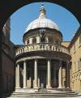

The Renaissance architecture emphasized the harmony and proportion. The stone was the main material. For the columns and decoration marble was used, while in the domes, bricks are preferred.

The influence of classical Greek antiquity becomes particularly evident in the pediments, the metopes, the friezes, the capitals, the columns, the pillars and the masks. It is strongly visible in columns. The architectural style of the columns affected by the Doric, Ionic and by the end of the Corinthian style.

 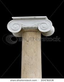 [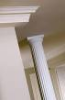](http://www.google.gr/imgres?q=%CE%BA%CE%AF%CE%BF%CE%BD%CE%B5%CF%82+%CE%B4%CF%89%CF%81%CE%B9%CE%BA%CE%BF%CF%8D+%CF%81%CF%85%CE%B8%CE%BC%CE%BF%CF%8D&hl=el&biw=1366&bih=508&gbv=2&tbm=isch&tbnid=Q0_IMI337OHraM:&imgrefurl=http://amaradi.wordpress.com/&docid=NeNJsBYdBhFtXM&imgurl=https://lh5.googleusercontent.com/_L-8WLlPyypo/TaA7v8FtaUI/AAAAAAAADc0/dlCqr9CLai8/19.jpg&w=334&h=512&ei=ilhoT7bpLuLN4QTGlOn9CA&zoom=1)

Important figures in the architecture of this period are the Leon Batista Alberti, Donato Angelo Bramante, Filippo Bruneleschi, Leonardo Da Vinci and Andrea Palladio. The designers are inspired by the Tuscan, Doric, Ionic, Corinthian style. The creations are characterized by simplicity and stunning beauty.

An excellent example of Renaissance architecture is the Cathedral of St. Peter in Rome, built with the encouragement of the Popes Julius II 'and Leo X' and designed by famous architects of the era, among them are Donat Bramante and Michelangelo.

[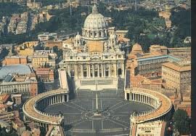](http://www.google.gr/imgres?q=internal+architecture+of+saint+peter+rome&hl=el&biw=1366&bih=508&gbv=2&tbm=isch&tbnid=4Jn4OKrx5jJVYM:&imgrefurl=http://www.online-literature.com/forums/showthread.php%3Ft%3D32270&docid=l2JVrhSed56gzM&imgurl=http://www.cs.utah.edu/~bigler/pictures/europe2002/italy/st%252520peter%2527s%252520basilica.jpg&w=860&h=596&ei=q1toT4aRCIWE4gS-qpT6CA&zoom=1)

The first project was awarded to Donato di Angelo di Paskoutsio, called Bramante, a painter and architect from the North who had already built in Rome two great works, the cloisters of Santa Maria del Pacha and the chapel of San Pietro in Montorio. The Bramante perceived preferences of Julius II, and presented the plans of a giant building, 24,000 square meters, with a flattened dome (similar to the one that dominated the Pantheon) and Greek cross-shaped (four aisles with the same length).

[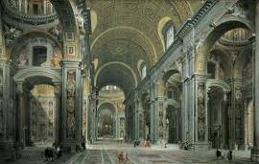](http://www.google.gr/imgres?q=internal+architecture+of+saint+peter+rome&hl=el&biw=1366&bih=508&gbv=2&tbm=isch&tbnid=o7OrR50mke8FPM:&imgrefurl=http://openbuildings.com/buildings/st-peters-basilica-profile-1450&docid=HZhzCGSBfj51LM&imgurl=http://c1038.r38.cf3.rackcdn.com/group1/building1450/media/uiqd_giovanni_paolo_panini_interior_of_st._peter27s2c_rome.jpg&w=600&h=382&ei=q1toT4aRCIWE4gS-qpT6CA&zoom=1)

To decorate the interior of the future basilica, Julius II commissioned Michelangelo to build an enormous mausoleum. Pope del Rovers wanted to be buried in the center of St. Peter, as the Apostle, under a tomb worthy of ambitions on Earth.

[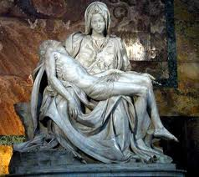](http://www.google.gr/imgres?q=%CE%B1%CE%B3%CE%B9%CE%BF%CF%82+%CF%80%CE%AD%CF%84%CF%81%CE%BF%CF%82+%CF%84%CE%B7%CF%82+%CF%81%CF%8E%CE%BC%CE%B7%CF%82+%CE%B5%CF%83%CF%89%CF%84%CE%B5%CF%81%CE%B9%CE%BA%CF%8C+%CF%84%CE%BF%CF%85+%CE%BD%CE%B1%CE%BF%CF%8D&um=1&hl=el&biw=1366&bih=508&tbm=isch&tbnid=Zg9cW-QrblmxJM:&imgrefurl=http://eicastikon.blogspot.com/2008_11_05_archive.html&docid=dNcYiZcf7qwU7M&imgurl=http://2.bp.blogspot.com/_qijUItx-tsQ/SRE6Wz4vVdI/AAAAAAAACTQ/AbIUKYDePm4/s400/michelangelo_pieta.jpg&w=400&h=356&ei=t2hnT9qhBsrcsgbf0qCyBQ&zoom=1)